**Araştırma Makalesi / Research Article**

**DOI: https://doi.org/10.35414/akufemubid.1424423**

AKÜ FEMÜBİD **24** (2024) 061003 (1275-1284) AKU J. Sci. Eng. **24** (2024) 061003 (1275-1284)

***\*Makale Bilgisi / Article Info***

Alındı/Received: 23.01.2024

Kabul/Accepted: 11.08.2024

Yayımlandı/Published: xx.xx.xxxx

|  |
| --- |
| **Immunotherapeutic and Cell-Protective Effects of Probiotic Kefir on Cyclophosphamide‐induced Nephrotoxicity and Urotoxicity in Rats** |
| **Probiyotik Kefirin Sıçanlarda Siklofosfamid Kaynaklı Nefrotoksisite ve Ürotoksisite Üzerine İmmünoterapötik ve Hücre Koruyucu Etkileri** |

**Songül ÇETİK YILDIZ1[](http://orcid.org/0000-0002-7855-5343) , Cemil DEMİR1[](https://orcid.org/0000-0002-6365-0196), Mustafa CENGİZ2*,[](http://orcid.org/0000-0002-6925-8371), Halit IRMAK3[](https://orcid.org/0000-0002-8184-9377) , Betül PEKER CENGİZ4[](https://orcid.org/0000-0002-2503-7446) ,**

**Adnan AYHANCİ5[](http://orcid.org/0000-0003-4866-9814)**

*1 Mardin Artuklu University, Health Services Vocational School, Department of Medical Services and Techniques, Mardin, Türkiye*

*2 Siirt University, Faculty of Education, Department of Elementary Education, Siirt, Türkiye*

*3 Mardin Artuklu University, Faculty of Engineering And Architecture, Department of Computer Sciences, Mardin, Türkiye*

*4 Eskisehir Yunus Emre State Hospital, Department of Pathology, Eskişehir, Türkiye*

*5 Eskişehir Osmangazi University, Faculty of Science, Department of Biology, Eskişehir, Türkiye*

© Afyon Kocatepe Üniversitesi

**Abstract**

To evaluate kefir, a naturally occurring fermented dairy product, with pharmacological and therapeutic qualities including antioxidant, anti-apoptotic, and anti-inflammatory effects against cyclophosphamide (CP)-induced hemorrhagic cystitis and nephrotoxicity in rats. For this purpose, experimental rats were divided into 6 groups; control (Group 1), 150 mg/kg CP (Group 2), 5 mg/kg kefir (Group 3), l0 mg/kg kefir (Group 4), 5 mg/kg kefir+150 CP (Group 5), l0 mg/kg kefir+150 CP (Group 6). Since there was no difference in kefirs fermented on different days, kefirs from the 1st, 2nd, and 3rd days were mixed and given to the rats for 12 days, while CP was given as an only dose and i.p. on the 12th day of the experiment. Histologic evaluations revealed that CP caused toxicity in the kidney and bladder. On the other hand, biochemical evaluations showed a significant increase in serum blood urea nitrogen (BUN) and creatinine (Cre) levels, which are tissue toxicity markers, and a significant decrease in catalase (CAT), glutathione (GSH), superoxide dismutase (SOD) and glutathione peroxidase (GPx) levels, which are intracellular antioxidant system markers, in the CP-treated experimental group. However, all values were reversed as a result of kefir (5 and 10 mg/kg) treatment. These results showed that kefir is an effective protective agent against CP-induced hemorrhagic cystitis and nephrotoxicity.

**Keywords:** Cyclophosphamide; Hemorrhagic cystitis; Immunotherapy; Kefir; Nephrotoxicity.**Öz**

Doğal olarak oluşan fermente bir süt ürünü olan kefirin, sıçanlarda siklofosfamid (CP) ile indüklenen hemorajik sistit ve nefrotoksisiteye karşı antioksidan, anti-apoptotik ve anti-inflamatuar etkileri gibi farmakolojik ve terapötik niteliklerini değerlendirmek. Bu amaçla, deneysel sıçanlar 6 gruba ayrılmıştır; control (Grup 1), 150 mg/kg CP (Grup 2), 5 mg/kg kefir (Grup 3), l0 mg/kg kefir (Grup 4), 5 mg/kg kefir+150 CP (Grup 5), l0 mg/kg kefir+150 CP (Grup 6). Farklı günlerde fermente edilen kefirlerde farklılık olmadığı için 1., 2. ve 3. gün kefirleri karıştırılarak sıçanlara 12 gün boyunca verilmiş, CP ise deneyin 12. gününde tek doz ve i.p. olarak verilmiştir. Daha sonra elde edilen parametreler değerlendirilmiştir. Histolojik değerledirmeler sonucunda CP'nin böbrek ve mesane de toksisiteye neden olduğu belirlenmiştir. Öte yandan biyokimyasal değerlendirme ile CP uygulanan deney grubunda, doku toksisite belirteçleri olan serum kan üre nitrojen (BUN) ve kreatinin (Cre) seviyelerindeki önemli artış görülğrken hücre içi antioksidan sistem belirteçlerinden olan katalaz (CAT), glutatyon (GSH), superoksit dismutaz (SOD) ve glutatyon peroksidaz (GPx) düzeylerinde ise önemli azalma olduğu belirlenmiştir. Bununla birlikte, kefir (5 ve 10 mg/kg) tedavisi neticesinde meydana gelen tüm değerler tersine dönmüştür. Bu sonuçlar kefirin CP kaynaklı hemorajik sistit ve nefrotoksisiteye karşı etkili bir koruyucu olduğunu göstermiştir.

**Anahtar Kelimeler:** Siklofosfamid; Hemorajik sistit; İmmünoterapi; Kefir; Nefrotoksisite.

**1. Introduction**

An essential tactic in the treatment of cancer is conventional chemotherapy. Anticancer medications interact with the DNA of cancer cells to regulate apoptosis and stop the cell cycle mechanism (Mills *et al.* 2019). Off-target organ damage, however, is a known drawback and catastrophic side effect of anticancer medication therapy. Undesirable developments can occasionally throw off treatment plans and patients' adherence to medicines (Ayhanci *et al.* 2020). Cyclophosphamide (CP) is a common chemotherapeutic and immunosuppressive agent widely used in the treatment of chronic autoimmune disorders and numerous cancer types (Cengiz *et al.* 2020). Bladder toxicity is the main factor restricting the use of CP and can cause potentially fatal hemorrhagic cystitis. Additionally, CP causes multi-organ toxicity in many tissues such as liver, kidney and heart in cancer patients (Cengiz 2018b, Çetik Yıldız *et al.* 2024, Qiu *et al.* 2023, Wróbel *et al.* 2019). Hemorrhagic cystitis is a bladder urotoxicity occurring in approximately 10-40% of patients receiving CP (Akbaş *et al.* 2022, Cengiz *et al.* 2022, Qiu *et al.* 2023, Wróbel *et al.* 2019). Studies have reported that the bladder-toxic hepatic metabolite of CP, acrolein, is linked to CP urotoxicity (Aboulhoda *et al.* 2020). Accumulating research evidence has shown that acrolein disrupts the antioxidant mechanism and bladder epithelium, aggravating the inflammatory responses and production of reactive oxygen species (ROS) (Cengiz *et al.* 2018, Fatima *et al.* 2022, Peng *et al.* 2022). Before utilizing hepatic microsomal cytochrome P450, most especially CYP2B6, to exert its therapeutic benefits, CP must first undergo metabolic activation (Haghi-Aminjan *et al.* 2018). When CP biotransformation occurs, acrolein is produced, and it has a wide range of toxicity. Because the kidneys express CYP2B6, the renal injury could result from the local production of poisonous acrolein (Cengiz 2018, Knights *et al.* 2013, Zanger and Klein 2013). CP-related nephrotoxicity may cause glomerular and tubular dysfunction with a decreased rate of glomerular filtration (Sugumar *et al.* 2007). Lipid peroxidation, cellular defense depletion, and ROS generation have been identified as the primary causes of glomerular injury and renal failure observed after CP treatment (Rehman *et al.* 2012). Many studies have reported a pro-oxidant effect of CP in experimental animals, increasing oxidative stress, inflammatory state, and apoptosis (Alhaithloul *et al.* 2019, Can *et al.* 2022, Cengiz *et al.* 2017, Germoush and Mahmoud 2014). It is noteworthy that the adverse effects of CP can be reduced by natural compounds (Gözüoğlu 2021, Yıldız 2020). Among these functional products, kefir has been found as a prebiotic with health-promoting properties in both experimental and clinical studies.

Kefir is an acidic and slightly alcoholic fermented dairy product originating from the Caucasus mountains (Cetik Yildiz *et al.* 2024, Urdaneta *et al.* 2007). Unlike other fermented milk products, this beverage is produced through fermentation using a mixed microflora contained within a matrix of individual "kefir grains," rather than the metabolic activity of an evenly distributed microflora (Kahraman *et al.* 2021; Marshall and Cole 1985). Grain microbial makeup varies depending on where the grain comes from. The genera that are most frequently reported are acetic acid bacteria, leuconostoc, lactobacilli, lactococci, and homofermentative and heterofermentative yeasts (Angulo *et al.* 1993, Toba 1987). The microorganisms that make up kefir grains include the production of antibiotics, bactericides, and lactic acid which prevent the growth of pathogens and unwanted microorganisms in kefir (Angulo *et al.* 1993). It has been stated that kefir positively affects antioxidant variables and reduces lipid peroxidation in carbon tetrachloride toxicity in mice (Cetik Yildiz *et al.* 2024; Güven *et al.* 2003). Kefir exhibits activities such as antioxidative, hematoptotective, cytoprotective (Yildiz and Gözüoğlu 2021), antimicrobial, and anticarcinogenic properties, and protection against apoptosis (Cetik Yildiz *et al.* 2019). Besides, Kefir protects kidney tissue in diabetic animal renal tissue by dramatically up-regulating Nrf2, modifying CAT and SOD, and significantly lowering NO, superoxide anion, and 3-NT (Pugliero *et al.* 2021). In another study, it was reported that kefir can prevent damage due to its protective properties on tissue and serum functions in ischemia/reperfusion-induced kidney injury (Yener *et al.* 2015). However, no study showing the effect of kefir on the urinary system was found in the literature. This experimental study was designed to demonstrate the adverse side effects of CP on the kidney as well as to demonstrate the possible protective role of kefir against CP-caused hemorrhagic cystitis and nephrotoxicity in rats. To our knowledge, no study has been found in the literature showing the effects of kefir on CP-caused urotoxicity and nephrotoxicity in rats.

**2. Materials and Methods**

***2.1 Fermentation of kefir***

In our study, commercially supplied and freeze-dried kefir yeast and 1 liter of cow's milk were preferred for kefir fermentation. Three groups of kefirs were created, with fermentation at 24-26 °C temperature at intervals of 24, 48, and 72 hours and days 1, 2, and 3. It was kept at +4 °C ready for use. We gave kefir to rats by gavage method for 12 days. Kefirs from the 1st, 2nd, and 3rd days were mixed and given by gavage method for 12 days Yildiz and Gözüoğlu 2021).

***2.2 Chemicals and injections***

Cyclophosphamide (CP) (Sigma-Aldrich) was commercially available. 500 mg CP was dissolved in 25 ml bidistilled water to prepare for injection of 150 mg/kg CP. The injection was performed as a single dose intraperitoneally (i.p.) / body-weight (b.w.) on the 12th day of the experiment, using sterile disposable syringes.

***2.3 Experimental setup***

In our experimental study, healthy, males, 200±20 gr, about 3 months age Wistar albino rats were used. During the experiment, the animals were kept in rooms with 12;12 light/dark lighting, 45-50% humidity, and 22±2 C˚ temperature. And were given tap water and normal pellet feed. The 42 rats used in this study were divided into 6 groups, each group including 7 rats. Kefir gavage method as mg/kg/body weight (b.w.) for 12 days was given. CP is a single dose and i.p. was given on the last day of the experiment (day 12). Group 1 was designated as control (0.5 mL, saline), 150 mg/kg/bw CP to rats in Group 2, 5 mg/kg/bw kefir was given to the rats in Group 3, 10 mg/kg/bw kefir to experimental animals of Group 4, 5 mg/kg/bw kefir + 150 mg/kg/bw CP for Group 5, and finally, 10 mg/kg/bw kefir + 150 mg/kg/bw CP was administered to the rats of Group 6. Following the research study, anesthesia was used to remove tissues (the kidney and bladder) and blood (for biochemical markers).

***2.4 Biochemical analysis***

Using the thiobarbituric acid (TBA) reagent method, MDA and GSH levels were measured with a spectrophotometer set at 520 nm and 412 nm respectively (Sedlak and Lindsay 1968). With the support of commercially available kits, the activity of the SOD enzyme was evaluated spectrophotometrically. Sun et al.'s (1988) protocol was followed when measuring the activity of the SOD enzyme (Sun *et al.* 1988). Using the Beers and Sizer method as reported by Usoh et al. (2005) serum CAT activity was measured by detecting the drop in absorbance at 240 nm caused by the breakdown of H2O2 (Usoh *et al.* 2005). GPX was measured by Rotruck et al. and showed no discernible change. Tris-Hcl buffer, hydrogen peroxide, glutathione, DNTB, TCA, Tris-EDTA, a homogenous tissue serum sample, and sodium azide were used in this experiment. Then, using an ELISA reader (AWARENESS STAT FAX-2100, USA), absorption was measured at 420 nm (Valibeik *et al.* 2020). The concentration of serum Cre was measured using the Jaffe technique (Kojima *et al*. 2013), and BUN was measured using the autoanalyzer (BT 3000) UV method.

***2.5 Statistical Analysis***

The quantitative values obtained at the end of the study were evaluated by applying the Duncan test after one-way ANOVA, which is used in the statistical analysis of more than two independent groups, using the SPSS 26.00 statistical data program.

**3. Results**

As seen in Figure 1, the control group’s rats had normal kidney structures. In contrast, the glomerular structure was atrophic and deformed in the CP group (Figure 1b), some cells were shed into the renal microcapsule, and there was a clear infiltration of inflammatory cells on one side. Also, there were discontinuities in the parietal cells and an incomplete renal microcapsule structure. In the proximal convoluted tubule lumen, there were exfoliated cells as well as some denatured cells that developed edema. Moreover, distal convoluted tubules with discrete and irregularly arranged cells were also visible. However, it was observed that the structure of the kidney in the kefir-given groups was importantly improved compared to the CP-induced group’s animals. Especially in the 10mg/kg kefir + CP group (Figure 1e), there was no evidence of inflammatory cell infiltration, and the glomerular structure was largely normal. In the 10 mg/kg kefir + CP group, the proximal convoluted tubules featured prominent brush-like borders and a tiny, irregular lumen. Capillaries in the interstitium were visible, as were the borders of the distal convoluted tubules. In conclusion, the 10 mg/kg kefir dose was more effective than the 5 mg/kg kefir dose in ameliorating CP-induced kidney damage.

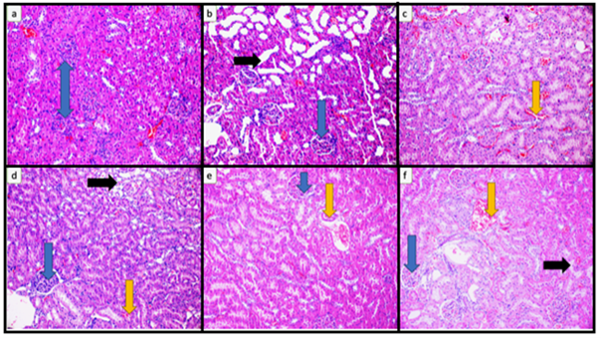

**Figure 1.** (a) Normal-looking tubules and glomeruli (blue arrow) in the kidney parenchyma of rats in the control group, (b) Glomeruli (blue arrow) and thyroidization (black arrow) in the kidney parenchyma of rats administered CP, (c) Congestion (yellow arrow) in the kidney parenchyma of rats given kefir, (d) Glomeruli (blue arrow), congestion (yellow arrow) and focal area thyroidization (black arrow) in the renal parenchyma of rats administered CP and kefir, (e) Congestion (yellow arrow) and glomeruli (blue arrow) in the renal parenchyma of rats administered kefir, (f) CP and congestion (yellow arrow), glomeruli (blue arrow) and thyroidization (black arrow) in the kidney parenchyma of rats administered kefir. (H&E, X200).

As seen in Figure 2, the bladder structure of the rats in the control and kefir groups appeared normal (Figure 2a). However, in the CP group (Figure 2b), widespread ulceration in the bladder epithelium, edema on the wall, inflammation, congestion, and blood and fibrin mass in the lumen were observed. However, it was observed that the bladder structure in the groups given kefir improved significantly compared to the CP group. Especially in the 10 mg/kg kefir + CP group (Figure 2e), regeneration in the bladder epithelium, mild edema on the wall, and mild inflammation were observed. As a result, the 10 mg/kg kefir dose was more effective than the 5 mg/kg kefir dose in improving CP-induced bladder damage.

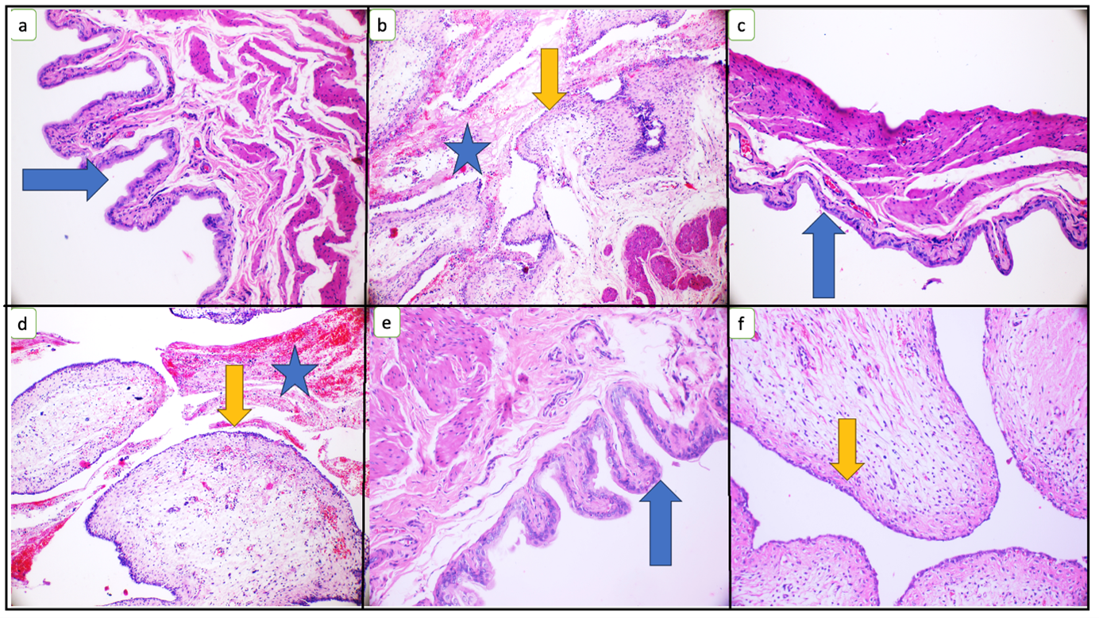

**Figure 2.** (a) Bladder epithelium (blue arrow) and bladder wall within normal limits, (b) Widespread ulceration in the bladder epithelium (yellow arrow), wall edema, inflammation, congestion, and blood and fibrin mass in the lumen (blue star), (c) Bladder epithelium (blue arrow). and bladder wall within normal limits, (d) Bladder epithelium (blue arrow) and bladder wall within normal limits, (e) Widespread erosion of the bladder epithelium (yellow arrow), edema on the wall, mild inflammation, congestion, and blood and fibrin mass in the lumen (blue star), (f) Regeneration in the bladder epithelium (yellow arrow), mild edema and mild inflammation on the wall. (H&E; X200)

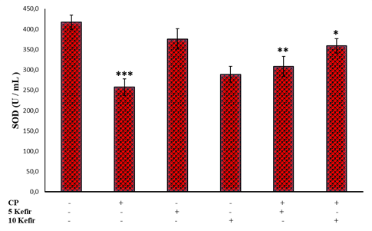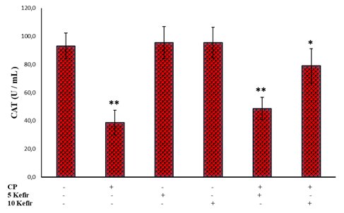

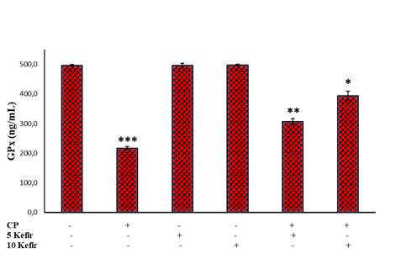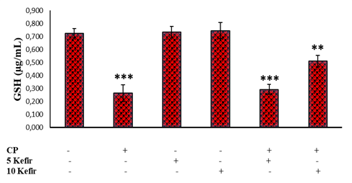

**Figure 3.** Showing the effect of CP and kefir on the levels of SOD, CAT, GPx, and GSH (*\*\*\* P<0.001; ** P<0.05; * p<0.01*)

CAT, SOD, GPx and GSH parameters have antioxidant effects in CP-induced toxicity. By measuring CAT, GPx, GSH, and SOD activity in the serum of control and CP-induced rats, the impact of kefir on the antioxidant system was observed. Figure 3 illustrates how the CP group's GSH, SOD, CAT, and GPx activities were importantly lower (*P<0.01*) than those of the control group. CAT, GSH-Px, and SOD activity rose in the CP-induced rats when they were given kefir at different dosages (5 and 10 mg/kg) as opposed to the CP group.

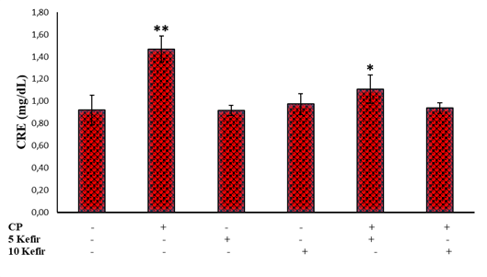

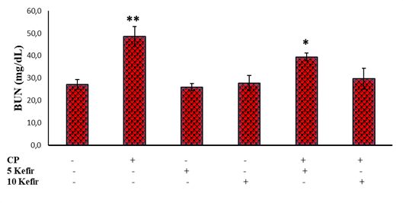

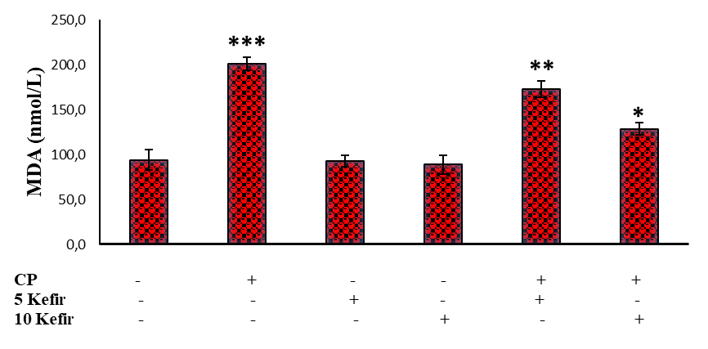

**Figure 4.** Showing the effect of CP and kefir on the levels, CRE (A), BUN (B), and MDA (C) (*\*\*\* P<0.001; ** P<0.05; * P<0.01*).

Serum CRE and BUN levels were measured to assess the preventive impact of kefir against CP-induced nephrotoxicity. As shown in Figure 4, When the CP group was compared to the control and kefir-treated groups, there was a substantial increase in both CRE and BUN levels (*P<0.05*). This indicates that CP may cause cell toxicities. These findings were in line with previous research on kidneys (Lin et al. 2020, Rehman et al. 2012, Sinanoglu et al. 2012). It's interesting to note that CRE and BUN levels were considerably lower in CP-induced rats treated with different kefir dosages than in the CP group (*P<0.01*). This suggests that kefir can effectively ameliorate CP-caused nephrotoxicity in rats. An essential indicator of endogenous lipid peroxidation is MDA. In comparison to the control and kefir groups, the CP group's MDA levels were considerably higher (*P<0.001*). Rats given 5 and 10 mg/kg kefir showed significantly lower MDA levels than those in the CP group (*P<0.05* and *0.01*). This shows that kefir can reduce MDA levels in CP-induced lipid peroxidation in rats (Figure 4).

**4. Discussion and Conclusions**

The kidneys are crucial for controlling blood volume and eliminating medications and poisons from the body. However, because of their great absorptive capacity, kidneys are susceptible to toxicity and damage. Despite the effectiveness of CP, which is widely used in the treatment of neoplastic diseases, its use is associated with nephrotoxicity and urotoxicity (bladder), which are the main limitations of CP-induced therapy (Alshahrani *et al.* 2022). Kefir is an acidic and slightly alcoholic fermented dairy product with antioxidant, antiapoptotic, anti-lipid peroxidation, and anti-inflammatory activities (Can *et al.* 2012, Hadisaputro 2011, Hadisaputro *et al*. 2012). So far, there are no reports on the use of kefir against CP-induced nephrotoxicity and bladder toxicity. Therefore, the purpose of this study was to examine the protective effect of kefir against CP-caused nephrotoxicity and bladder damage through the antioxidant response pathway. Drugs' ability to protect the kidneys is frequently assessed using two key renal function markers, CRE and BUN (Aladaileh *et al*. 2019, Alhaithloul *et al*. 2019). The increased serum CRE and BUN levels after CP administration observed in this study are consistent with reports published in the literature(Abraham and Isaac 2011, AlHaithloul *et al*. 2019, Caglar *et al*. 2002, Temel *et al*. 2020). The increase in the serum levels of these enzymes may be due to the leakage of these cytosolic enzymes into the circulatory system as a result of kidney damage after CP administration. This is indicative of the onset of kidney damage due to renal dysfunction and change in membrane permeability due to impairment in the biosynthesis of these enzymes. With kefir administration, a sharp decrease in serum BUN and CRE levels was seen, preserving renal cellular membrane integrity, and subsequently preventing CP-induced renal toxicity. This is indicative of the possible nephroprotective activity offered by kefir compared to the untreated and CP-treated groups.

Histopathological studies also provided supporting validation for biochemical parameters demonstrated by photomicrographs. In the kidney tissue of CP-treated rats (Figure 1), There was clear inflammatory cell infiltration on one side, the glomerular structure was atrophic and deformed, and some cells were lost into the kidney microcapsule. Additionally, the renal microcapsule lacked some structural integrity, and the parietal cells were irregularly shaped. In the proximal convoluted tubule lumen, there were exfoliated cells as well as some denatured cells that developed edema. Furthermore, distal convoluted tubules with discrete and irregularly arranged cells were also visible. These histopathological findings were compatible with findings in the literature (Caglayan *et al*. 2018, Lin *et al*. 2020, Rehman *et al*. 2012). The main histological finding of this study was that kefir affected the recovery of CP-induced renal structure. One of the most significant side effects of CP chemotherapy is bladder damage (Davis and Kuttan 2000, Manesh and Kuttan 2005, Lin *et al*. 2020). The acute effect of CP is necrosis of the urothelium, with only a few cells surviving after 24 hours. Since the bladder is the place where urine accumulates, the level of toxic metabolites of CP is higher in the bladder than in other organs (Beyer-Boon *et al*. 1978, Valibeik *et al*. 2020). CP-induced bladder damage is mainly associated with renal excretion of acrolein, which is known to be a urotoxic metabolite of CP (Gray *et al*. 1986, Cengiz *et al*. 2018). Urothelial damage has been shown to occur in direct contact with acrolein, causing necrosis, edema, ulceration, bleeding, and leukocyte infiltration. Acrolein causes highly reactive free radicals, consumes cellular thiol, and disrupts the antioxidant defense mechanism of tissues (Mythili *et al*. 2004, Ayhanci *et al*. 2020). In addition to these side effects, it has also been reported that CP application causes oxidative stress by producing free radicals and ROS (McDermott and Powell 1996, Cetik Yildiz *et al*. 2024). These findings are compatible with our study results.

In this study, the level of MDA was examined using it as a key indicator for lipid peroxidation. MDA level, which indicates oxidative stress caused by CP, increased in the CP group compared to the control group. On the other hand, the significant decrease in plasma MDA level with kefir therapy compared to the CP group indicates that its protective effects on kidney and bladder tissues may be due to the antioxidant properties of kefir. This study is also compatible with the literature results (El-Shabrawy *et al*. 2020, Ijaz *et al*. 2022, Jiang *et al*. 2020). Kidney and bladder damage caused by CP is commonly associated with the pro-oxidant qualities of acrolein due to its ability to collect ROS, leading to oxidative stress and depression of the antioxidant functions (Jiang *et al*. 2020, Mahmoud *et al*. 2017). Numerous studies have shown that CP depletes antioxidative enzymes like SOD, GSH, CAT, and GPx and increases lipid peroxidation and ROS in the kidneys and bladder of CP-exposed animals (Jiang *et al*. 2020, Lin *et al*. 2020). Similarly, results from this study showed important decreases in renal activities of GSH, SOD, GPx, and CAT in CP-administered rats indicating oxidative damage. Kefir exhibited significant antioxidant activity through the restoration of antioxidative activities (high SOD, CAT, GPx, and GSH capacities). This result is consistent with previous reports on the antioxidant activity of kefir (El Golli-Bennour *et al.* 2019, Punaro *et al*. 2014).

The results of this study showed that oxidative stress, decreased antioxidant capacity, and lipid peroxidation are closely related to CP-caused bladder and kidney toxicity, and kefir has protective effects on these CP-caused toxicities. The protective effects of kefir are probably thanks to increasing the decreasing antioxidant capacity and reducing oxidative stress and lipid peroxidation.

**Declaration of Ethical Standards**

This study was approved by the Ethics Committee of Eskisehir Osmangazi University Animal Experiments Local Ethics Committee (784-145/2020). The authors declare that they comply with all ethical standards.

**Credit Authorship Contribution Statement**

Author-1: Methodology / Study design, Software, Validation, Formal analysis, Investigation

Author-2: Methodology / Study design, Software, Validation, Formal analysis, Investigation

Author-3: Writing – original draft, Writing – review and editing, Visualization, Supervision

Author-4: Investigation, Resources, Data curation, Writing – original draft

Author-5: Visualization, Project administration, Funding acquisition

Author-6: Project administration, Funding acquisition

**Declaration of Competing Interest**

The authors have no conflicts of interest to declare regarding the content of this article.

**Data Availability**

All data generated or analyzed during this study are included in this published article.

**Acknowledgment**

This experimental research was financed by Mardin Artuklu University / Coordination Unit of Scientific Research Project (MAU.BAP.20. SHMYO.004).

**5. References**

Aboulhoda, B.E., Amin, S.N., Thomann, C., Youakim, M., and Hassan, S.S., 2020. Effect of thymoquinone on cyclophosphamide-induced injury in the rat urinary bladder. *Archives of Medical Science*, 16, 1-12

https://doi.org/10.5114/aoms.2020.97061

Abraham, P. and Isaac, B., 2011. The effects of oral glutamine on cyclophosphamide-induced nephrotoxicity in rats. *Human & experimental toxicology*, *30*, 616-623.

https://doi.org/10.1177/0960327110376552

Akbaş, N., Suleyman, B., Mammadov, R., Yazıcı, G. N., Bulut, S., Süleyman, H., 2022. Effect of taxifolin on cyclophosphamide-induced oxidative and inflammatory bladder injury in rats. *Experimental Animals*, **71** (4), 460-467.

https://doi.org/10.1538/expanim.22-0030

Aladaileh, S.H., Hussein, O.E., Abukhalil, M.H., Saghir, S.A., Bin-Jumah, M., Alfwuaires, M. A., Mahmoud, A.M., 2019. Formononetin upregulates Nrf2/HO-1 signaling and prevents oxidative stress, inflammation, and kidney injury in methotrexate-induced rats. *Antioxidants*, **8** (10), 430.

https://doi.org/10.3390/antiox8100430

Alhaithloul, H.A.S., Alotaibi, M.F., Bin-Jumah, M., Elgebaly, H., Mahmoud, A.M., 2019. Olea europaea leaf extract up-regulates Nrf2/Are/HO-1 signaling and attenuates cyclophosphamide-induced oxidative stress, inflammation and apoptosis in rat kidney. *Biomedicine & Pharmacotherapy*, **111**, 676-685.

https://doi.org/10.1016/j.biopha.2018.12.112

Alshahrani, S., Ali Thubab, H.M., Ali Zaeri, A.M., Anwer, T., Ahmed, R.A., Jali, A.M., Alam, M.F., 2022. The protective effects of sesamin against cyclophosphamide-induced nephrotoxicity through modulation of oxidative stress, inflammatory-cytokines and apoptosis in rats. *International Journal of Molecular Sciences*, **23** (19), 11615.

https://doi.org/10.3390/ijms231911615

Angulo, L., Lopez, E. and Lema, C., 1993. Microflora present in kefir grains of the galician region (north-west of spain). *Journal of Dairy Research*, **60**(2), 263-267.

https://doi.org/10.1017/S002202990002759X

Ayhanci, A., Tanriverdi, D.T., Sahinturk, V., Cengiz, M., Appak-Baskoy, S., Sahin, I.K., 2020. Protective effects of boron on cyclophosphamide-induced bladder damage and oxidative stress in rats. *Biological Trace Element Research*, **197**(1), 184-191.

https://doi.org/10.1007/s12011-019-01969-z

Beyer-Boon, M.E., De Voogt, H.J. and Schaberg, A. (1978). The effects of cyclophosphamide treatment on the epithelium and stroma of the urinary bladder. *European Journal of Cancer (1965)*, **14**(10), 1029-1035.

https://doi.org/10.1016/0014-2964(78)90057-9

Caglar, K., Kinalp, C., Arpaci, F., Turan, M., Saglam, K., Ozturk, B., Vural, A., 2002. Cumulative prior dose of cisplatin as a cause of the nephrotoxicity of high‐dose chemotherapy followed by autologous stem‐cell transplantation. *Nephrology Dialysis Transplantation*, **17**(11), 1931-1935.

https://doi.org/10.1093/ndt/17.11.1931

Caglayan, C., Temel, Y., Kandemir, F.M., Yildirim, S., Kucukler, S., 2018. Naringin protects against cyclophosphamide-induced hepatotoxicity and nephrotoxicity through modulation of oxidative stress, inflammation, apoptosis, autophagy, and DNA damage. *Environmental Science and Pollution Research*, **25**(21), 20968-20984.

https://doi.org/10.1007/s11356-018-2242-5

Can, E., Kurtoğlu, İ.Z., Benzer, F., Erişir, M., Kocabaş, M., Kızak, V., Çelik, H.T., 2012. The effects of different dosage of kefir with different durations on growth performances and antioxidant system in the blood and liver tissues of çoruh trout (salmo coruhensis). *Turkish Journal of Fisheries Aquatic Sciences*, **12**(2), 277-283.

https://doi.org/10.4194/1303-2712-v12_2_12

Can, S., Çetik Yıldız, S., Keskin, C., Şahintürk, V., Cengiz, M., Appak Başköy, S., Akıncı, G., 2022. Investigation into the protective effects of hypericum triquetrifolium turra seed against cyclophosphamide-induced testicular injury in sprague dawley rats. *Drug and Chemical Toxicology*, **45**(4), 1679-1686.

https://doi.org/10.1080/01480545.2020.1856130

Cengiz, M., 2018a. Boric acid protects against cyclophosphamide-induced oxidative stress and renal damage in rats. *Cellular and Molecular Biology*, **64**(12), 11-14.

https://doi.org/10.14715/cmb/2018.64.12.3

Cengiz, M., 2018b. Ratlarda siklofosfamid nedenli kardiyotoksisite üzerine borik asitin koruyucu etkileri. *Bitlis Eren Üniversitesi Fen Bilimleri Dergisi*, 7(1), 113-118.

https://doi.org/10.17798/bitlisfen.415381

Cengiz, M., Ayhancı, A. and Kutlu, H.M., 2020. Investigation into the protective effects of escin on blood cells and cyclophosphamide-induced bone marrow toxicity in rats. [Siklofosfamid Nedenli Kan Hücreleri ve Kemik İliği Toksisitesi Üzerine Escinin Koruyucu Etkilerinin Sıçanlarda Araştırılması]. *Bilecik Şeyh Edebali Üniversitesi Fen Bilimleri Dergis*i, **7**(2), 730-738.

https://doi.org/10.35193/bseufbd.677193

Cengiz, M., Ayhancı, A., Lafçı, N., Musmul, A., Gür, F., Vejselova Sezer, C., Onur, S., 2022. The protective effects of selenium and boron against cyclophosphamide-induced bone marrow and blood toxicity: An in vivo study. *Biological Diversity and Conservation*, **15**(2), 256-264.

https://doi.org/10.46309/biodicon.2022.1124346

Cengiz, M., Tekin, Y., İnal, B., Ayhancı, A., 2017. Kekik bitkisinin temel bileşeni olan karvakrolün sıçanlarda siklofosfamid nedenli üreme sistemi hasarı üzerine koruyucu etkileri. *Türkiye Tarımsal Araştırmalar Dergisi*, **4**(2), 171-175.

https://doi.org/ 10.19159/tutad.295505

Cengiz, M., Yeşildağ, Ö. and Ayhancı, A., 2018. Siklofosfamid nedenli hematoksisite üzerine karvakrolün sitoprotektif etkileri. *Türkiye Tarımsal Araştırmalar Dergisi*, **5**(2), 125-130.

https://doi.org/ 10.19159/tutad.378717

Cetik Yildiz, S., Demir, C., Cengiz, M., & Ayhanci, A. (2019). Protective properties of kefir on burn wounds of mice that were infected with s. Aureus, p. Auroginasa and E. Coli. *Cellular and Molecular Biology*, **65**(7), 60-65.

https://doi.org/10.14715/cmb/2019.65.7.11

Cetik Yildiz, S., Demir, C., Cengiz, M., Irmak, H., Cengiz, B. P., Ayhanci, A., 2024. In vitro antitumor and antioxidant capacity as well as ameliorative effects of fermented kefir on cyclophosphamide-induced toxicity on cardiac and hepatic tissues in rats. *Biomedicines*, **12**(6), 1199.

https://doi.org/10.3390/biomedicines12061199

Cetik Yildiz, S., Demir, C., Cengiz, M., Irmak, H., Peker Cengiz, B., Ayhanci, A., 2024. The protection afforded by kefir against cyclophosphamide induced testicular toxicity in rats by oxidant antioxidant and histopathological evaluations. *Scientific Reports*, **14**(1), 18463.

https://doi.org/10.1038/s41598-024-67982-y

Çetik Yıldız, S., Demir, C., Cengiz, M., Peker Cengiz, B., Ayhancı, A., 2024. Evaluation of in vitro antioxidative and protective effects of kefir on cyclophosphamide-upon oxidative stress and lung damage in rats. *Bingöl Üniversitesi Sağlık Dergisi*, **5**(1), 11-18.

https://doi.org/10.58605/bingolsaglik.1436057

Davis, L. and Kuttan, G., 2000. Effect of withania somnifera on cyclophosphamide-induced urotoxicity. *Cancer letters*, **148**(1), 9-17.

https://doi.org/10.1016/S0304-3835(99)00252-9

El-Shabrawy, M., Mishriki, A., Attia, H., Emad Aboulhoda, B., Emam, M., Wanas, H., 2020. Protective effect of tolvaptan against cyclophosphamide-induced nephrotoxicity in rat models. *Pharmacology Research & Perspectives*, **8**(5), e00659.

https://doi.org/10.1002/prp2.659

El Golli-Bennour, E., Timoumi, R., Annaibi, E., Mokni, M., Omezzine, A., Bacha, H., Abid-Essefi, S., 2019. Protective effects of kefir against deltamethrin-induced hepatotoxicity in rats. *Environmental Science and Pollution Research*, **26**(18), 18856-18865.

https://doi.org/10.1007/s11356-019-05253-4

Fatima, M., Anjum, I., Abdullah, A., Abid, S. Z., & Malik, M. N. H. (2022). Boswellic acids, pentacyclic triterpenes, attenuate oxidative stress, and bladder tissue damage in cyclophosphamide-induced cystitis. ACS Omega, 7(16), 13697-13703.

https://doi.org/10.1021/acsomega.1c07292

Germoush, M. O., & Mahmoud, A. M. (2014). Berberine mitigates cyclophosphamide-induced hepatotoxicity by modulating antioxidant status and inflammatory cytokines. Journal of Cancer Research and Clinical Oncology, 140(7), 1103-1109.

https://doi.org/10.1007/s00432-014-1665-8

Gözüoğlu, G. (2021). Sıçanlarda siklofosfamid ile oluşturulmuş hematoksisite ve myelotoksisite üzerine kefirin olası hücre koruyucu etkileri. Mardin Artuklu Üniversitesi,

Gray, K.J., Engelmann, U.H., Johnson, E.H., Fishman, I.J., 1986. Evaluation of misoprostol cytoprotection of the bladder with cyclophosphamide (cytoxan) therapy. *The Journal of Urology*, **136**(2), 497-500.

https://doi.org/10.1016/S0022-5347(17)44929-9

Güven, A., Güven, A. and Gülmez, M., 2003. The effect of kefir on the activities of gsh-px, gst, cat, gsh and lpo levels in carbon tetrachloride-induced mice tissues. *Journal of Veterinary Medicine, Series B*, **50**(8), 412-416.

https://doi.org/10.1046/j.1439-0450.2003.00693.x

Hadisaputro, S., 2011. Effects of oral clear kefir probiotics on glycemic status, lipid peroxidation, antioxidative properties of streptozotocin induced hyperglycemia wistar rats. *Gizi Indonesia*, **34**(1).

Hadisaputro, S., Djokomoeljanto, R. and Soesatyo, M., 2012. The effects of oral plain kefir supplementation on proinflammatory cytokine properties of the hyperglycemia wistar rats induced by streptozotocin. *Acta Medica Indonesiana*, **44**(2), 100-104.

Haghi-Aminjan, H., Asghari, M.H., Farhood, B., Rahimifard, M., Hashemi Goradel, N., Abdollahi, M., 2018. The role of melatonin on chemotherapy-induced reproductive toxicity. *Journal of Pharmacy Pharmacology*, **70**(3), 291-306.

https://doi.org/10.1111/jphp.12855

Ijaz, M.U., Mustafa, S., Batool, R., Naz, H., Ahmed, H., and Anwar, H., 2022. Ameliorative effect of herbacetin against cyclophosphamide-induced nephrotoxicity in rats via attenuation of oxidative stress, inflammation, apoptosis and mitochondrial dysfunction. *Human & Experimental Toxicology*, **41**, 09603271221132140.

https://doi.org/10.1177/09603271221132140

Jiang, S., Zhang, Z., Huang, F., Yang, Z., Yu, F., Tang, Y., Ding, G., 2020. Protective effect of low molecular weight peptides from solenocera crassicornis head against cyclophosphamide-induced nephrotoxicity in mice via the keap1/nrf2 pathway. *Antioxidants*, **9**(8), 745.

https://doi.org/10.3390/antiox9080745

Jiang, X., Ren, Z., Zhao, B., Zhou, S., Ying, X., Tang, Y., (-2020). Ameliorating effect of pentadecapeptide derived from cyclina sinensis on cyclophosphamide-induced nephrotoxicity. *Marine Drugs,* **18**(9), 462.

https://doi.org/10.3390/md18090462

Kahraman, M., Ertekin, Y.H. and Satman, İ., 2021. The effects of kefir on kidney tissues and functions in diabetic rats. *Probiotics and Antimicrobial Proteins*, **13**(2), 375-382.

https://doi.org/10.1007/s12602-020-09698-9

Knights, K.M., Rowland, A. and Miners, J.O., 2013. Renal drug metabolism in humans: The potential for drug–endobiotic interactions involving cytochrome p450 (cyp) and udp-glucuronosyltransferase (ugt). *British Journal of Clinical Pharmacology*, **76**(4), 587-602.

https://doi.org/10.1111/bcp.12086

Kojima, N., Slaughter, T.N., Paige, A., Kato, S., Roman, R. J., Williams, J.M., 2013. Comparison of the development diabetic induced renal disease in strains of goto-kakizaki rats. J*ournal of diabetes & metabolism*, Suppl **9**(5): S9-005.

https://doi.org/10.4172/2155-6156.S9-005

Lin, X., Yang, F., Huang, J., Jiang, S., Tang, Y., Li, J., 2020. Ameliorate effect of pyrroloquinoline quinone against cyclophosphamide-induced nephrotoxicity by activating the Nrf2 pathway and inhibiting the nlrp3 pathway. *Life Sciences*, **256**, 117901.

https://doi.org/10.1016/j.lfs.2020.117901

Mahmoud, A.M., Germoush, M.O., Alotaibi, M.F., Hussein, O.E., 2017. Possible involvement of nrf2 and pparγ up-regulation in the protective effect of umbelliferone against cyclophosphamide-induced hepatotoxicity. *Biomedicine & Pharmacotherapy*, **86**, 297-306.

https://doi.org/10.1016/j.biopha.2016.12.047

Manesh, C. and Kuttan, G., 2005. Effect of naturally occurring isothiocyanates in the inhibition of cyclophosphamide-induced urotoxicity. *Phytomedicine*, **12**(6), 487-493.

https://doi.org/10.1016/j.phymed.2003.04.005

Marshall, V.M. and Cole, W.M., 1985. Methods for making kefir and fermented milks based on kefir. *Journal of Dairy Research*, **52**(3), 451-456.

https://doi.org/10.1017/S0022029900024353

McDermott, E.M. and Powell, R.J., 1996. Incidence of ovarian failure in systemic lupus erythematosus after treatment with pulse cyclophosphamide. *Annals of the Rheumatic Diseases*, **55**(4), 224.

https://doi.org/10.1136/ard.55.4.224

Mills, K.A., Chess-Williams, R. and McDermott, C., 2019. Novel insights into the mechanism of cyclophosphamide-induced bladder toxicity: Chloroacetaldehyde’s contribution to urothelial dysfunction in vitro. *Archives of Toxicology*, **93**(11), 3291-3303.

https://doi.org/10.1007/s00204-019-02589-1

Mythili, Y., Sudharsan, P.T., Selvakumar, E., Varalakshmi, P., 2004. Protective effect of dl-α-lipoic acid on cyclophosphamide induced oxidative cardiac injury. *Chemico-Biological Interactions*, **151**(1), 13-19.

https://doi.org/10.1016/j.cbi.2004.10.004

Peng, X., Zhang, X., Wang, C., Olatunji, O.J., 2022. Protective effects of asperuloside against cyclophosphamide-induced urotoxicity and hematotoxicity in rats. *Open Chemistry*, **20**(1), 1444-1450.

https://doi.org/10.1515/chem-2022-0234

Pugliero, S., Lima, D.Y., Rodrigues, A.M., Bogsan, C.S.B., Rogero, M.M., Punaro, G.R., Higa, E.M.S., 2021. Kefir reduces nitrosative stress and upregulates nrf2 in the kidney of diabetic rats. *International Dairy Journal*, **114**, 104909.

https://doi.org/10.1016/j.idairyj.2020.104909

Punaro, G.R., Maciel, F.R., Rodrigues, A.M., Rogero, M.M., Bogsan, C.S.B., Oliveira, M.N., Higa, E.M.S., 2014. Kefir administration reduced progression of renal injury in stz-diabetic rats by lowering oxidative stress. *Nitric Oxide*, **37**, 53-60.

https://doi.org/10.1016/j.niox.2013.12.012

Qiu, H., Li, J., Huang, Y., Shen, C., Dai, L., Su, Q., Li, W., 2023. Sulfhydryl functionalized hyaluronic acid hydrogels attenuate cyclophosphamide-induced bladder injury. *Biomedical Materials*, **18**(1), 015026.

https://doi.org/10.1088/1748-605X/acadc2

Rehman, M.U., Tahir, M., Ali, F., Qamar, W., Lateef, A., Khan, R., Sultana, S., 2012. Cyclophosphamide-induced nephrotoxicity, genotoxicity, and damage in kidney genomic DNA of swiss albino mice: The protective effect of ellagic acid. *Molecular and Cellular Biochemistry*, **365**(1), 119-127.

https://doi.org/10.1007/s11010-012-1250-x

Sedlak, J. and Lindsay, R.H., 1968. Estimation of total, protein-bound, and nonprotein sulfhydryl groups in tissue with ellman's reagent. *Analytical biochemistry*, **25**, 192-205.

Sinanoglu, O., Yener, A.N., Ekici, S., Midi, A., Aksungar, F. B., 2012. The protective effects of spirulina in cyclophosphamide induced nephrotoxicity and urotoxicity in rats. *Urology*, **80**(6), 1392.e1391-1392.e1396.

https://doi.org/10.1016/j.urology.2012.06.053

Sugumar, E., Kanakasabapathy, I. and Abraham, P., 2007. Normal plasma creatinine level despite histological evidence of damage and increased oxidative stress in the kidneys of cyclophosphamide treated rats. *Clinica chimica acta; international journal of clinical chemistry*, **376**(1-2), 244-245.

https://doi.org/10.1016/j.cca.2006.04.006

Sun, Y., Oberley, L.W. and Li, Y., 1988. A simple method for clinical assay of superoxide dismutase. *Clinical chemistry*, **34**(3), 497-500.

Temel, Y., Kucukler, S., Yıldırım, S., Caglayan, C., Kandemir, F.M., 2020. Protective effect of chrysin on cyclophosphamide-induced hepatotoxicity and nephrotoxicity via the inhibition of oxidative stress, inflammation, and apoptosis. Naunyn-Schmiedeberg's *Archives of Pharmacology*, **393**(3), 325-337.

https://doi.org/10.1007/s00210-019-01741-z

Toba, T., 1987. Comparative study of polysaccharides from kefir grains, an encapsulated homofermentative lactobacillus species and lactobacillus kefir. *Milchwissenschaften*, **42**, 565-568.

Urdaneta, E., Barrenetxe, J., Aranguren, P., Irigoyen, A., Marzo, F., Ibáñez, F.C., 2007. Intestinal beneficial effects of kefir-supplemented diet in rats. *Nutrition Research*, **27**(10), 653-658.

https://doi.org/10.1016/j.nutres.2007.08.002

Usoh, I., Akpan, E., Etim, E., Farombi, E., 2005. Antioxidant actions of dried flower extracts of hibiscus sabdariffa l. On sodium arsenite-induced oxidative stress in rats. *Pakistan journal of Nutrition*, **4**(3), 135-141.

Valibeik, A., Naderi, N., Amini, A., Dastjerd, N.T., Monfared, S.R., Jafaripour, L., Ahmadvand, H., 2020. Effect of camphor on biochemical factors and gene expression of antioxidant enzymes, inflammatory and apoptotic factors against gentamicin-induced nephrotoxicity in rats. *Journal of Renal Injury Prevention*, **10**(3), e21-e21.

https://doi.org/10.34172/jrip.2021.21

Wróbel, A., Serefko, A., Bańczerowska-Górska, M., Szopa, A., Dudka, J., Poleszak, E., 2019. Intravesical administration of blebbistatin prevents cyclophosphamide-induced toxicity of the urinary bladder in female wistar rats. *Neurourology and urodynamics*, **38**(4), 1044-1052.

https://doi.org/10.1002/nau.23973

Yener, A., Sehitoglu, M., Ozkan, M., Bekler, A., Ekin, A., Cokkalender, O., Ozcan, S., 2015. Effects of kefir on ischemia-reperfusion injury. *European Review for Medical Pharmacological Sciences*, **19**(5), 887-896.

Yıldız, S.C. 2020. Properties and health benefits of probiotic and prebiotic kefir. *Academic Studies in Science Mathematics*-II, **59**.

Yildiz, S.Ç. and Gözüoğlu, G., 2021. Myeloprotective and hematoprotective role of kefir on cyclophosphamide toxicity in rats. *Archives of Clinical Experimental Medicine*, **6**(2), 77-82.

https://doi.org/10.25000/acem.903843

Zanger, U. and Klein, K., 2013. Pharmacogenetics of cytochrome p450 2b6 (cyp2b6): Advances on polymorphisms, mechanisms, and clinical relevance. *Frontiers in genetics*, **4** (24).

https://doi.org/10.3389/fgene.2013.00024